**Registration process for codevita**

* Click on the link <https://codevita.tcsapps.com/> it will take to the page show below

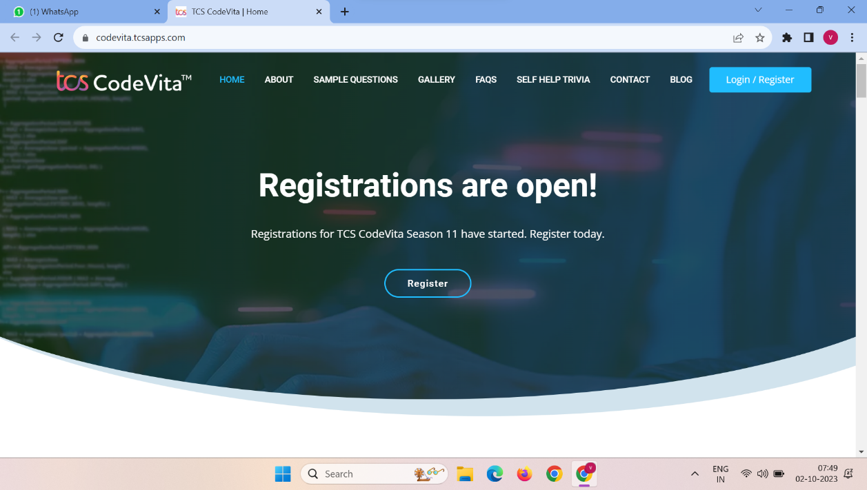

* Click on register

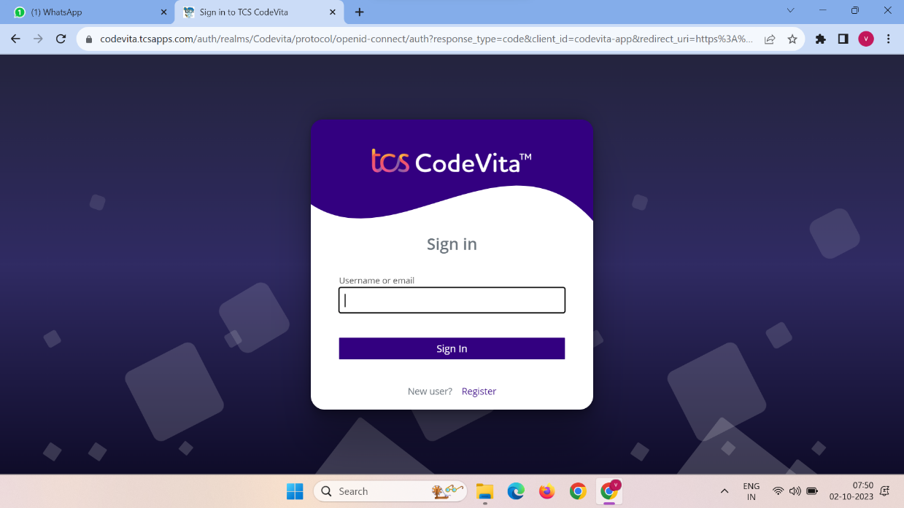

* Click on new user register

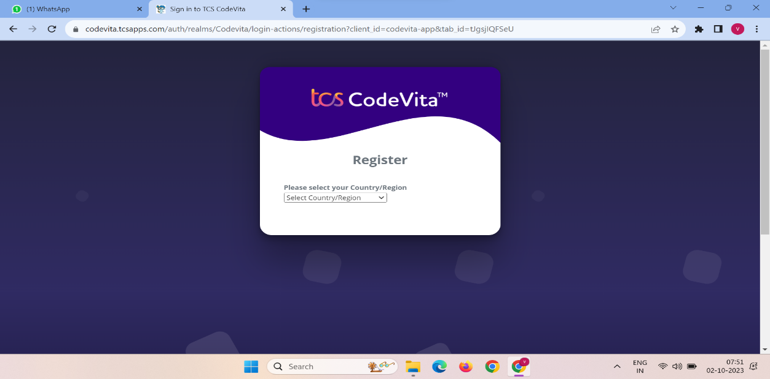

* Select the country india and fill the details

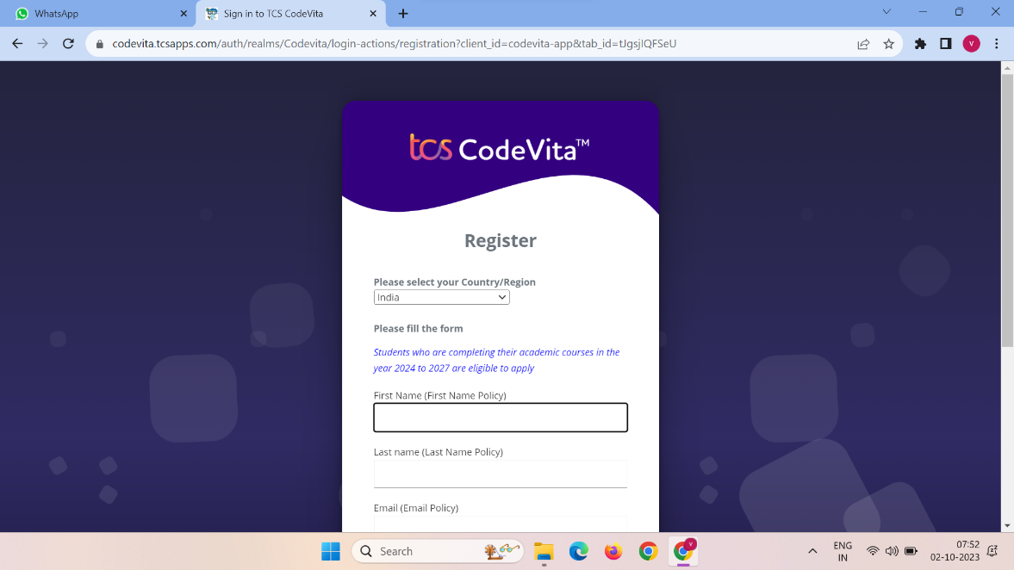

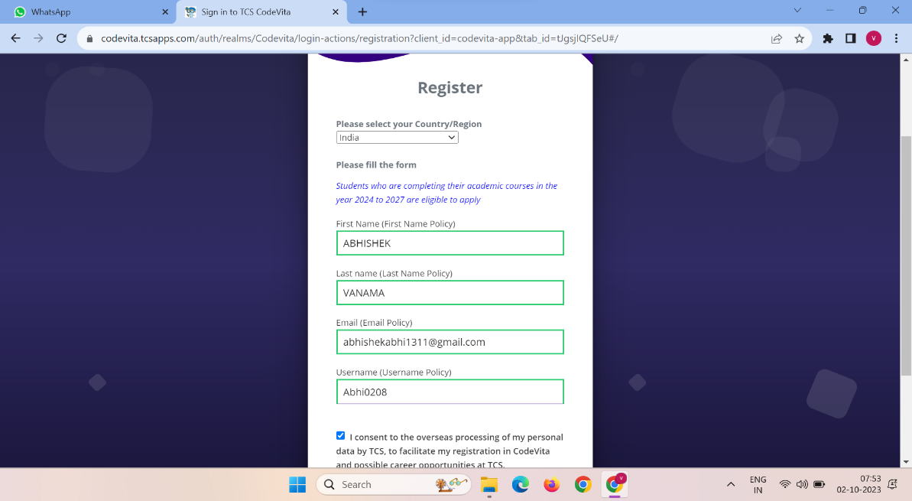

* After submitting the above form the below page is appear
* Download Microsoft Authendicator from playstore and open the application and scan the barcode
* Then an otp is generated in the app and enter the otp and click on submit

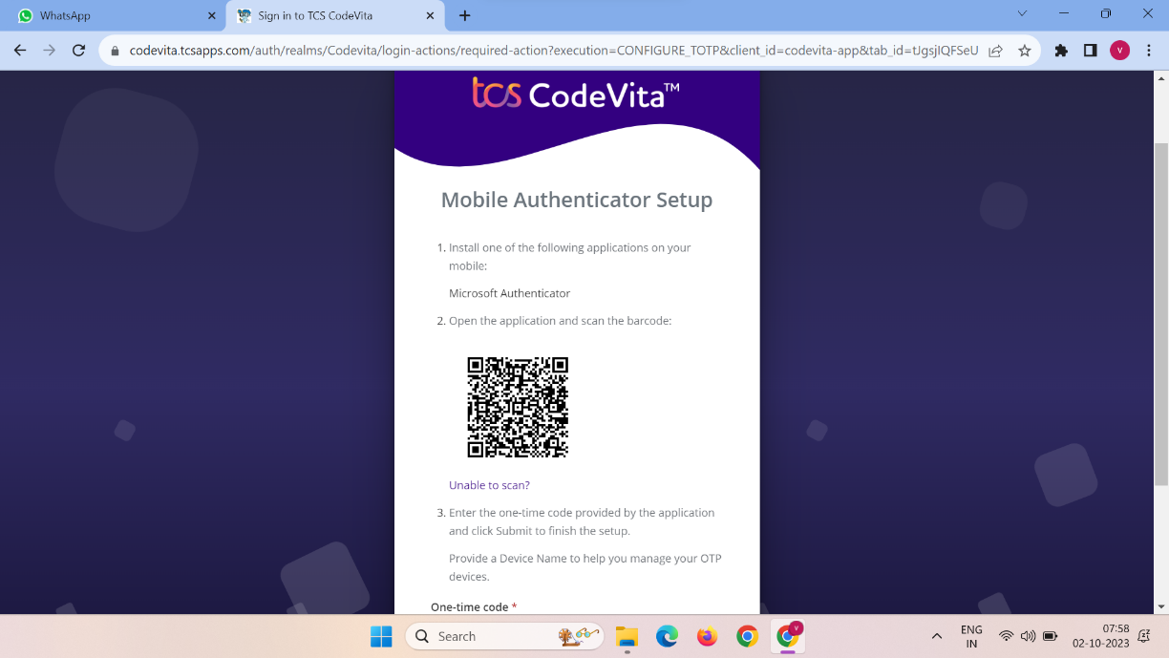

* After submitting the opt the registration page will open enter the details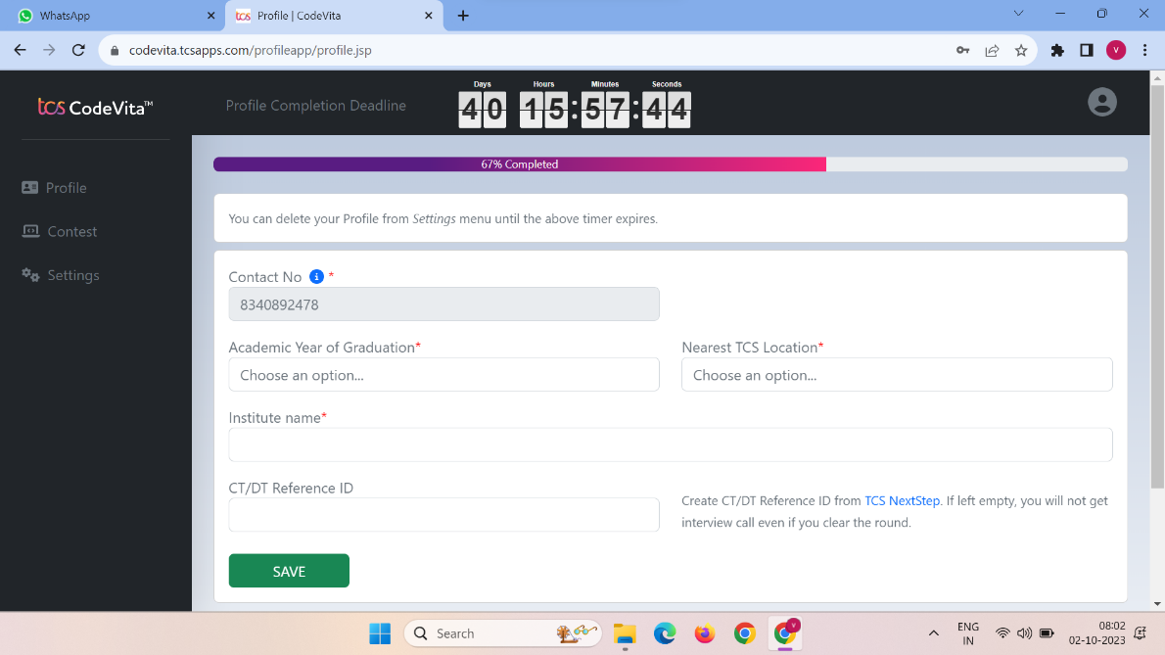

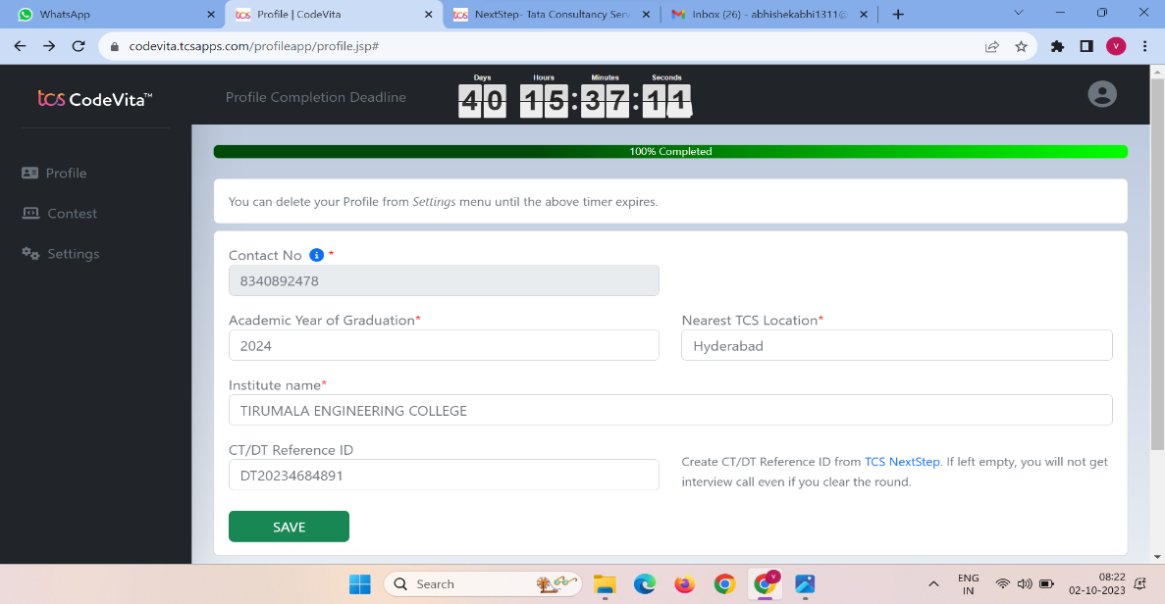

* For dt/ct number click on tcs nextstep which is present right side of the field and the page will appear like this and click register now



* Click on IT

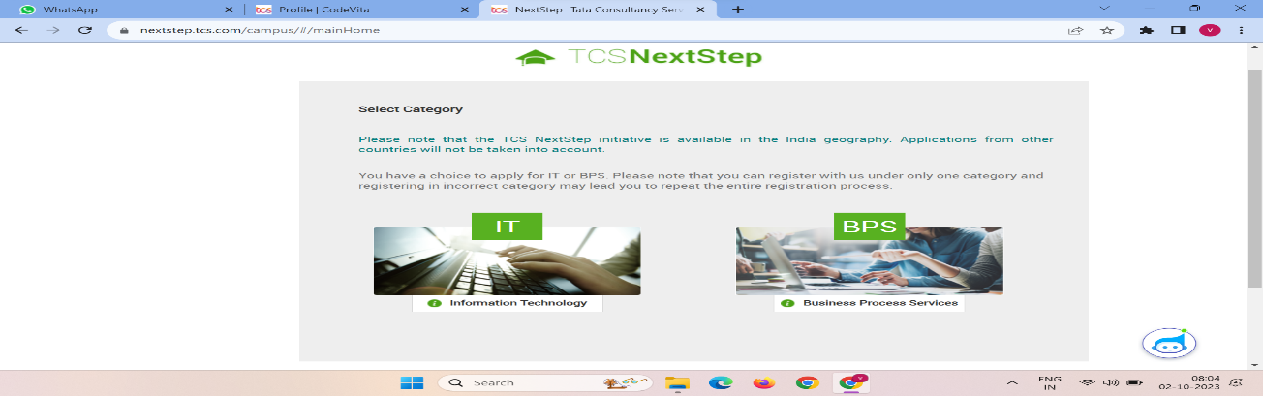

* Enter your email id

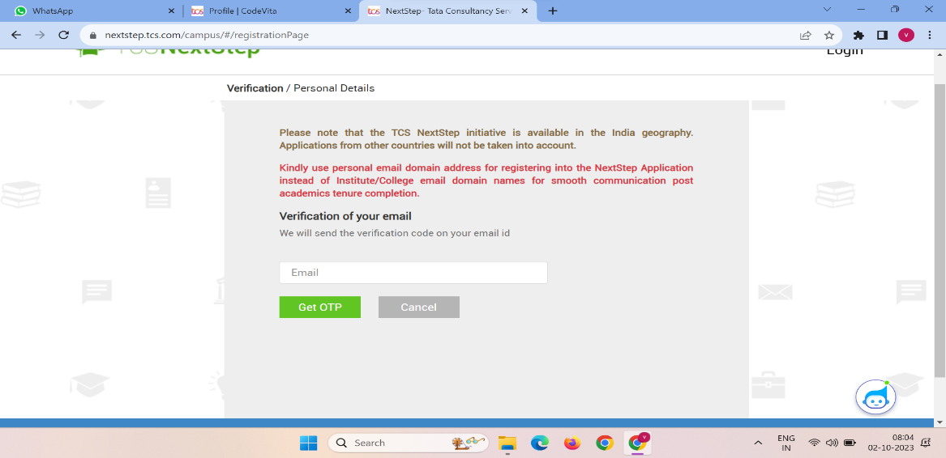

* Enter the otp and submit

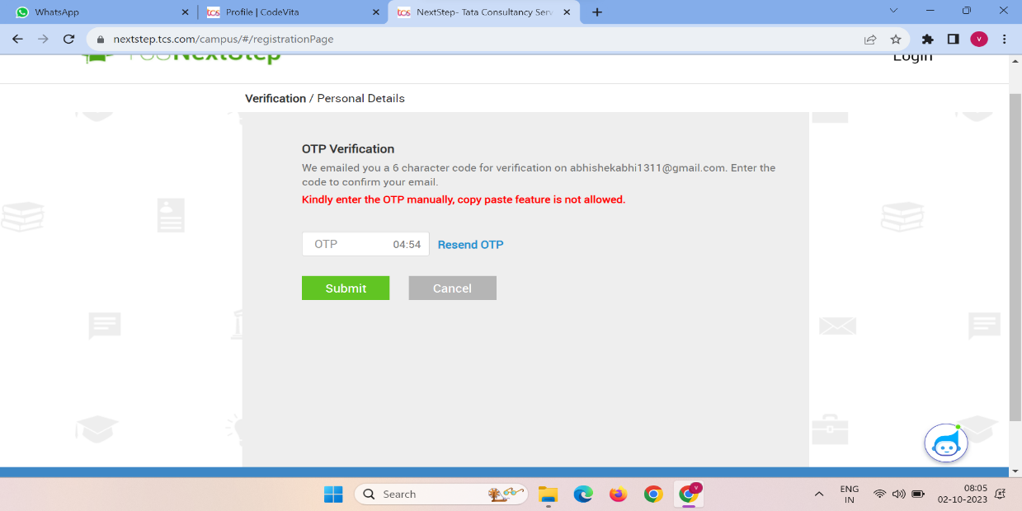

* After registration form will appear and fill the form

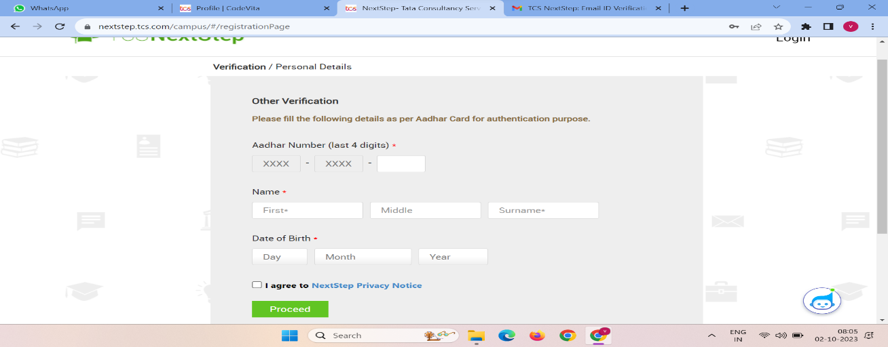

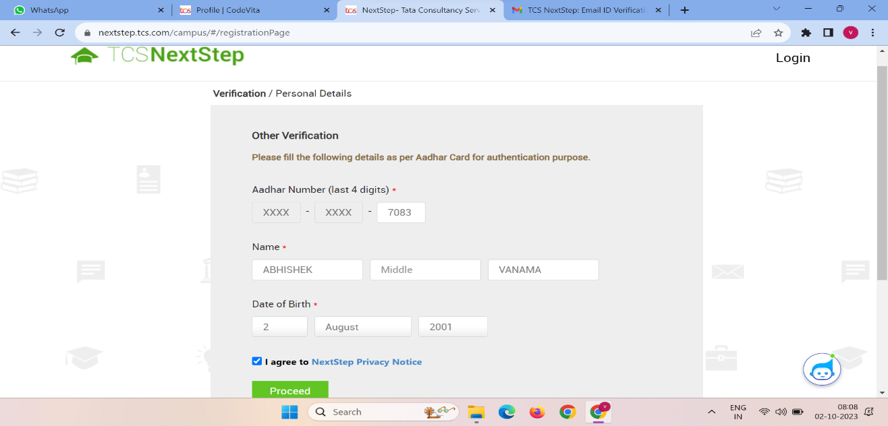

* After filling in the form click on proceed and fill the remaining details and click on submit

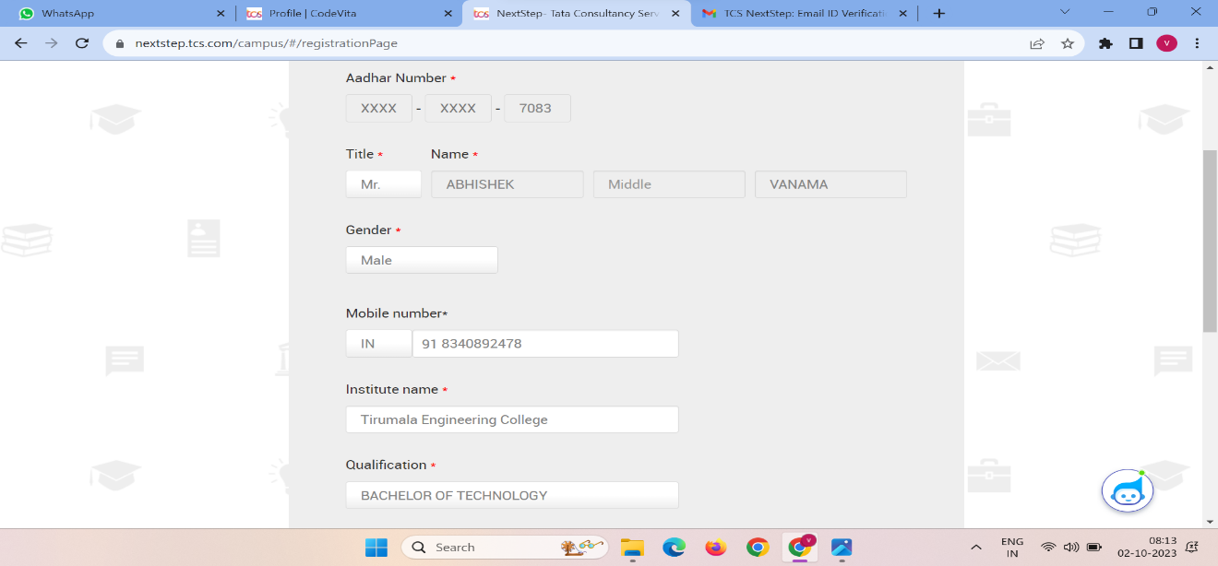

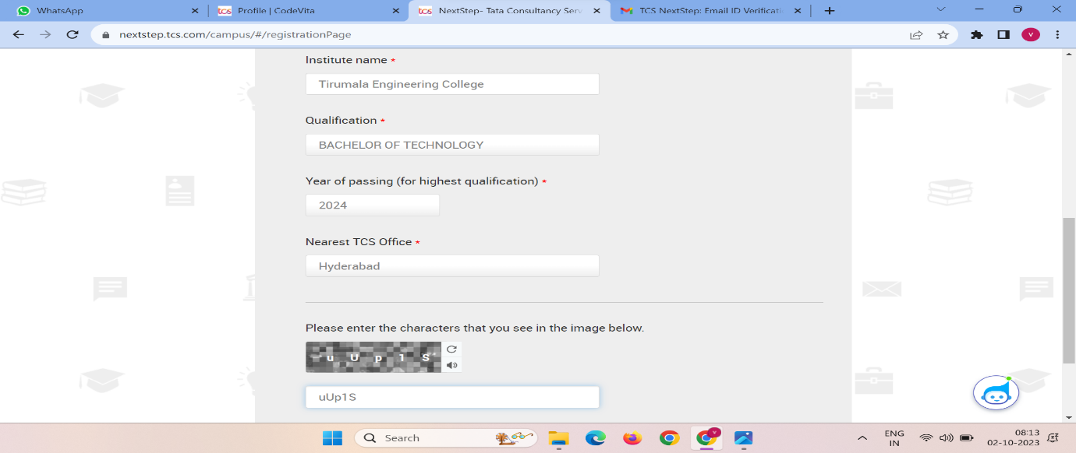

* After submitting the form it will generate the DT/CT number copy and paste the number in codevita registration form

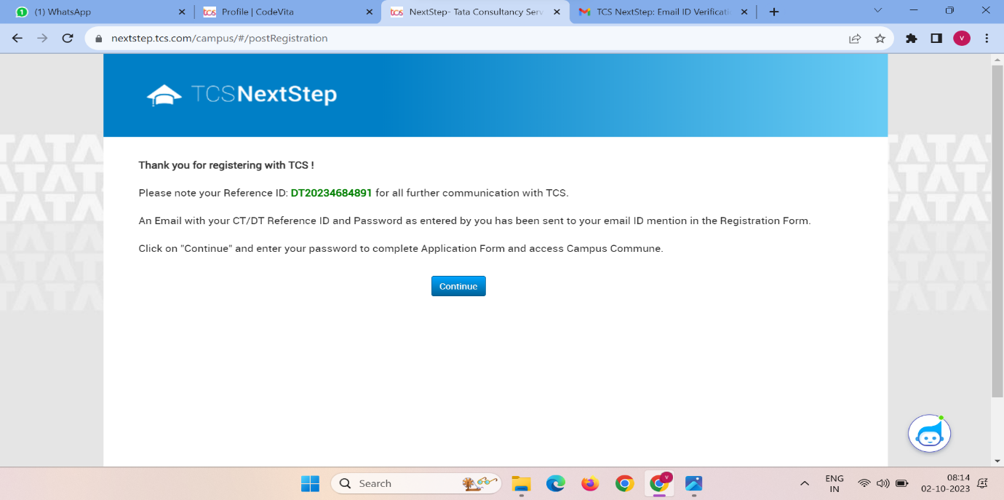



* And click on save button